**Aim**

To isolate the responses to the two primary climate drivers (NPP and SST) for each marine ecosystem model, in order to better understand why they respond differently.

**Approach**

Compare four/five experimental runs in which factors are modified in different combinations of pre-industrial and climate-change forcing.

**Proposed model runs:** All runs will be from 1860 to 2100. We will provide forcing data.

1. **Pre-industrial:** All forcings pre-industrial
2. **Climate-change:** All forcings historical + RCP8.5
3. **NPP control:** All forcings pre-industrial *except* NPP use climate-change (as per run 2) forcing
4. **Temperature control:** All forcings pre-industrial *except* temperature use climate-change (as per run 2) forcing
5. **All other variables:** (Optional but very helpful) All forcings climate change (as per run 2) except temperature and NPP pre-industrial (as per run 1)

**GCM:** IPSL only (TBC)

**Fishing effort:** None

**Forcing definitions:**

NPP-related forcing: includes whatever lower trophic level inputs related to Net Primary Production are used by the model (phytoplankton, NPP, zooplankton etc.)

Temperature: all water temperature variables used by the model (sea surface, bottom, etc.)

**List of model output required**

For all models, the output is the first 4 rows from Table 5 in Tittensor et al. (2018) (reproduced below). (i) Total system carbon biomass; (ii) total consumer carbon biomass; (iii) carbon biomass density of consumers > 10cm; (iv) carbon biomass density of consumers > 30cm. Please let us know wet weight to carbon ratios used, if relevant.

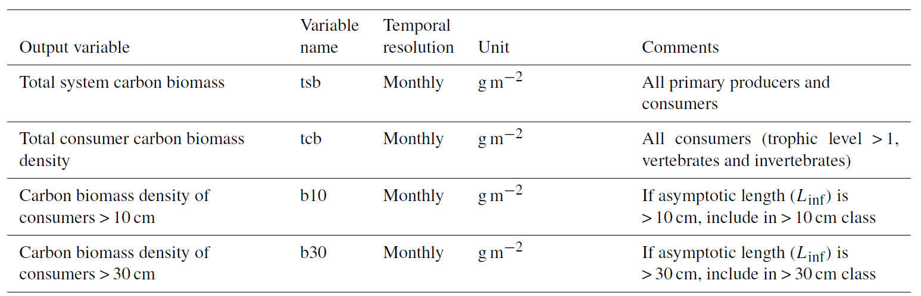

**Output data format**  
Depth integrated 1x1 degree grid squares at monthly resolution (yearly if model only run on annual time step). NetCDF with naming convention to follow.